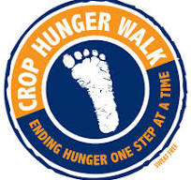

This year Dudley High School students will be participating in the Greensboro CROP Walk to help end hunger. If you would like to participate in the event to help end hunger, mark your calendar now and make plans to attend!

Sunday, October 6th

Barber Park, Greensboro, NC

**Mrs. Key**: 1:30 PM

**Walk Time**: 2:30 PM

**Walk Distance**: 5K

T-shirts are needed to participate in this event and they are $7 each. **You must have a t-shirt to enter the event.** Please use the form below to order your shirt and turn it in by Friday, September 20th to Mrs. Key.

**CASH ONLY, please bring exact change.**

Name: _____________________________________________

Phone: _____________________________________________

Email: ______________________________________________

Shirt Size: ______________________________

***\*\*\*Deadline to order shirts is September 20th\*\*\****